Steps to Create IBM Cloud Account

Step 1 Visit to the IBM Cloud login Page by clicking on the link given below:

Link:<https://www.ibm.com/academic/home>

Step-2 Click on register

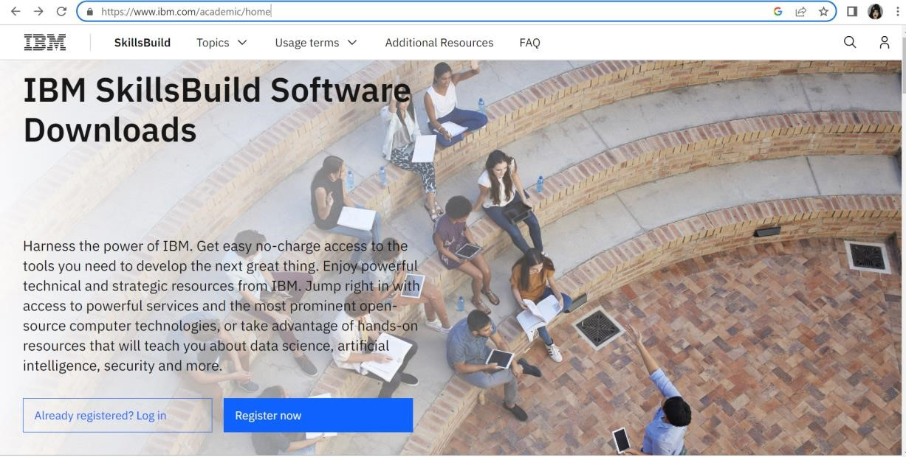

# Step-3 Enter your academic institution or smartinternz email issued to begin

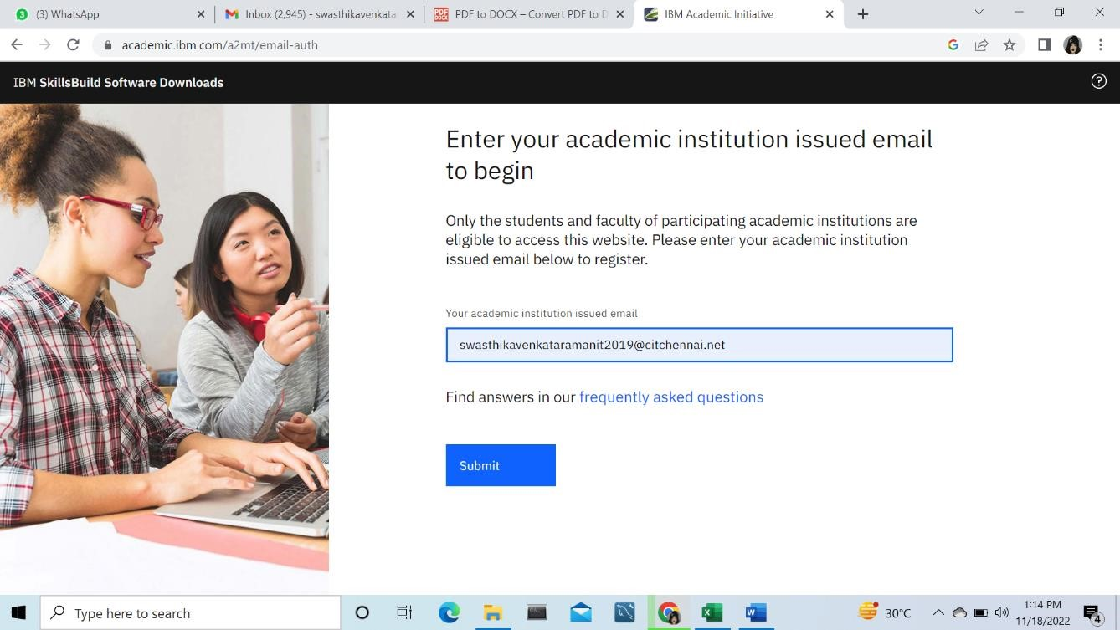

Step-4 Enter the below details for registration

## 1.Role

## 2.Current Degree

## 3.Department

## 4.Agree and Register

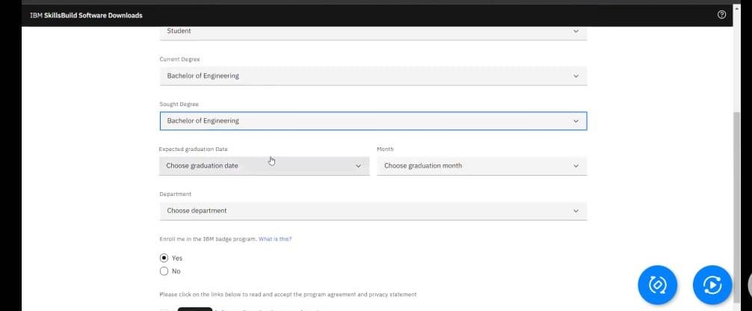

Step-5 To create the ibm account enter the below details

## 1.Acoount information

## 2.Additinal Information

## 3.Verify email

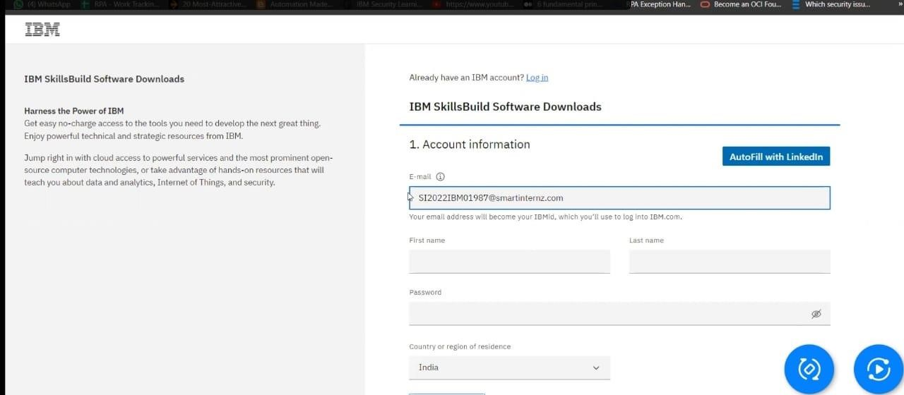

Step-6 To activate the IBM id

## 1.Go to Webmail provided or your institutional email and copy the verification code 2.Paste the id and click verify

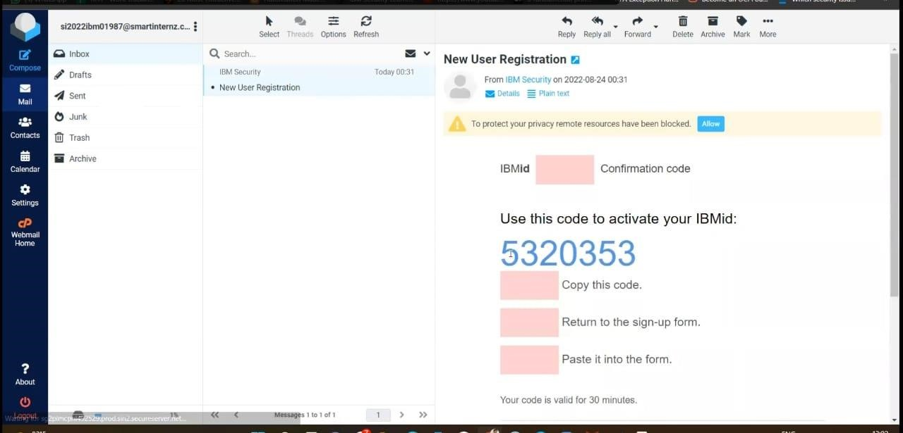

Step-7 To create IBM cloud

1.Click on the IBM cloud

2.Scroll down and go to software, Click on IBM cloud feature

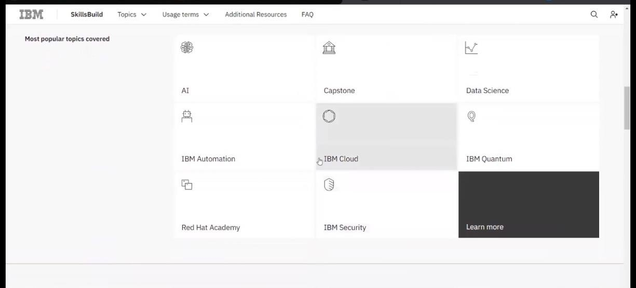

3.Click on request feature code

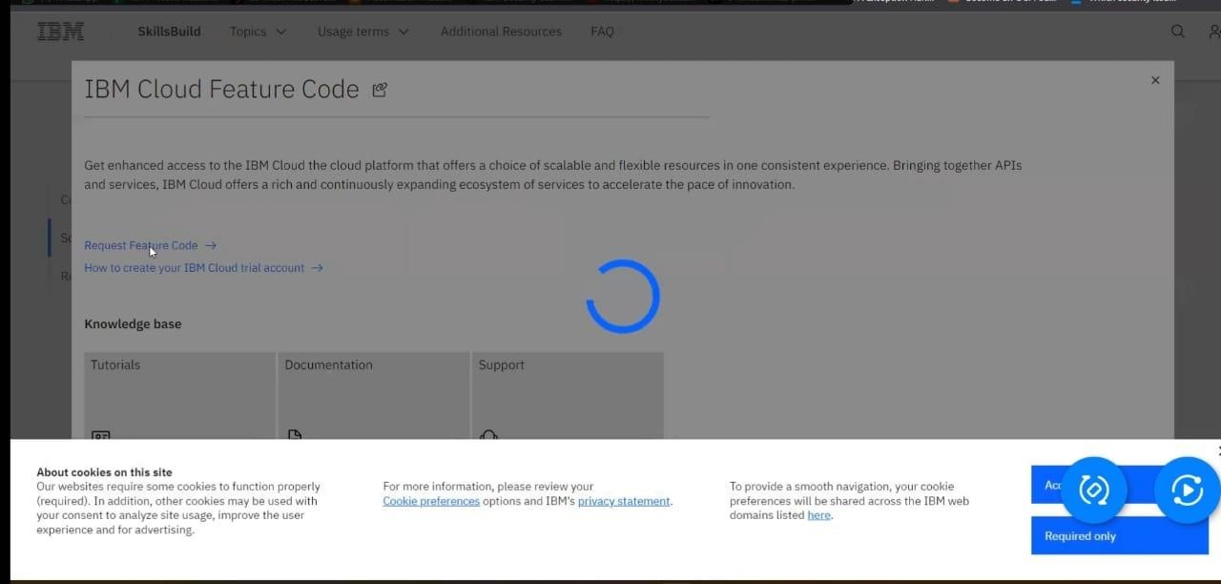

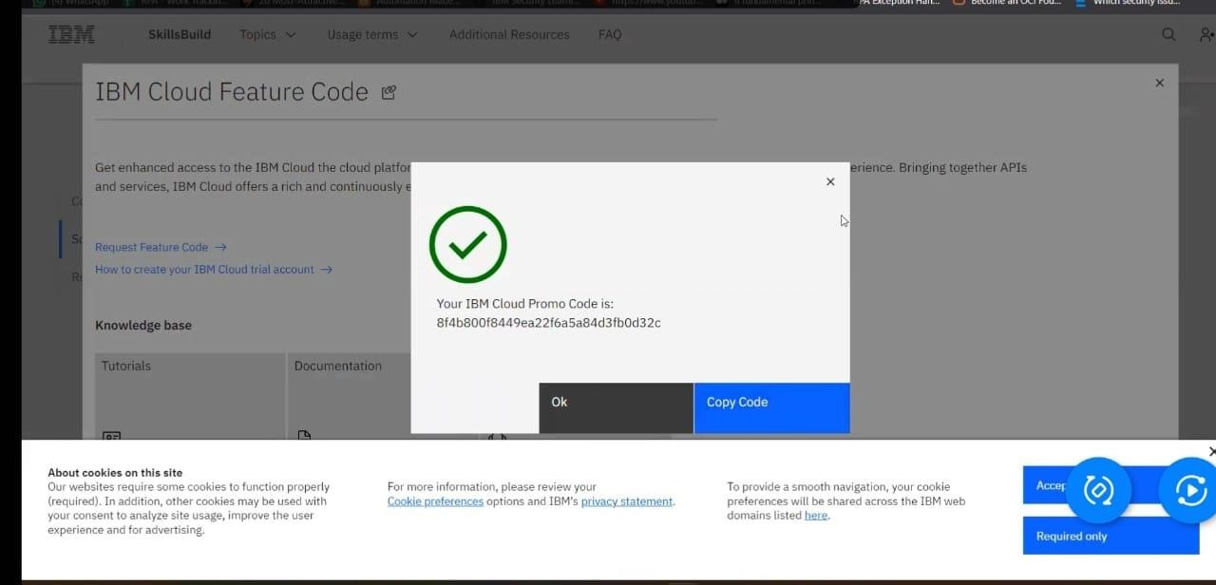

Step-8 Provide the same credentials i.e email id & password used for IBM account creation and click on next to get the OTP on the registered email id.

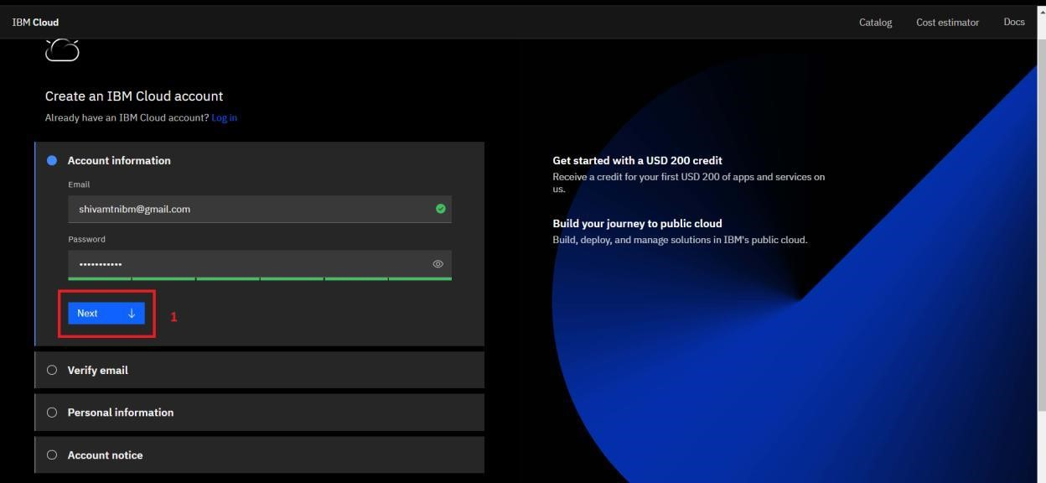

Step-9 Provide the received OTP on the registered email id and click on next

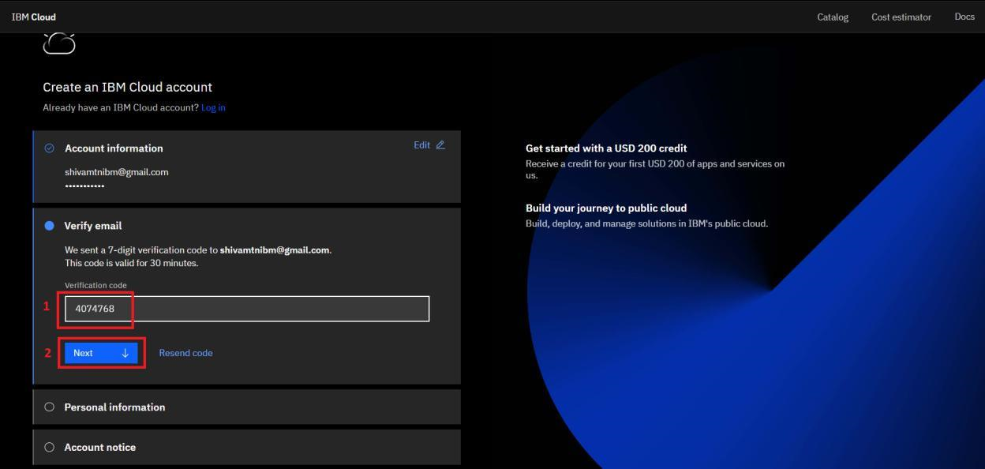

Step-10 Provide personal information and click on next

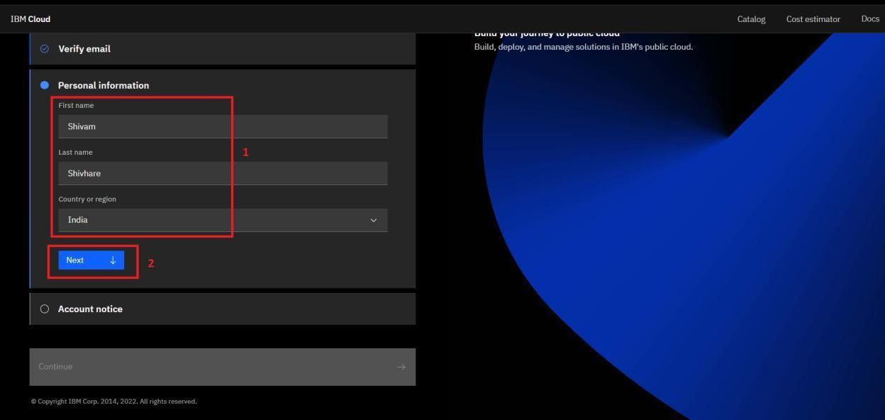

Step-11 Accept the terms and conditions then click on continue

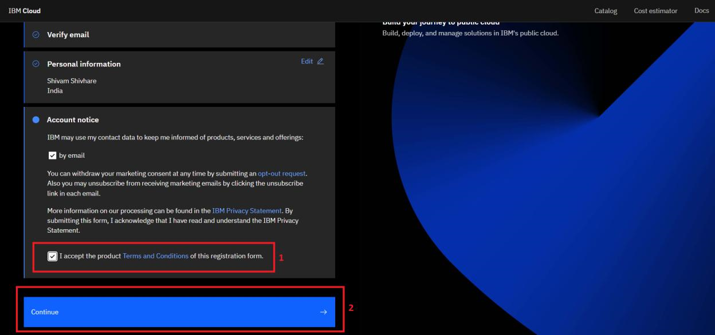

Step-12 Review account privacy notice mark the checkbox then click on continue

Step-13 Refer to Step-9 to copy the feature code or continue with the filled feature code then click on create account

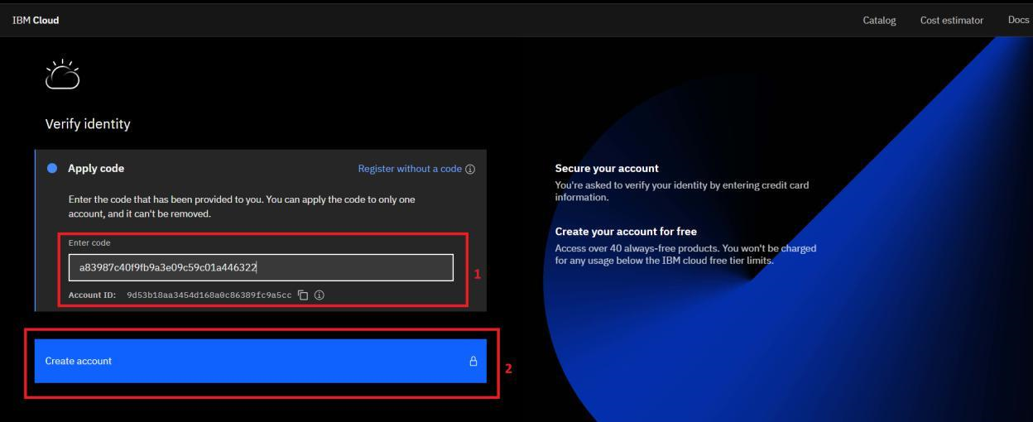

Step-14 After Successfully creating the account you are redirected to the dashboard page of the IBM Cloud account.

Team leader- Moniessh P

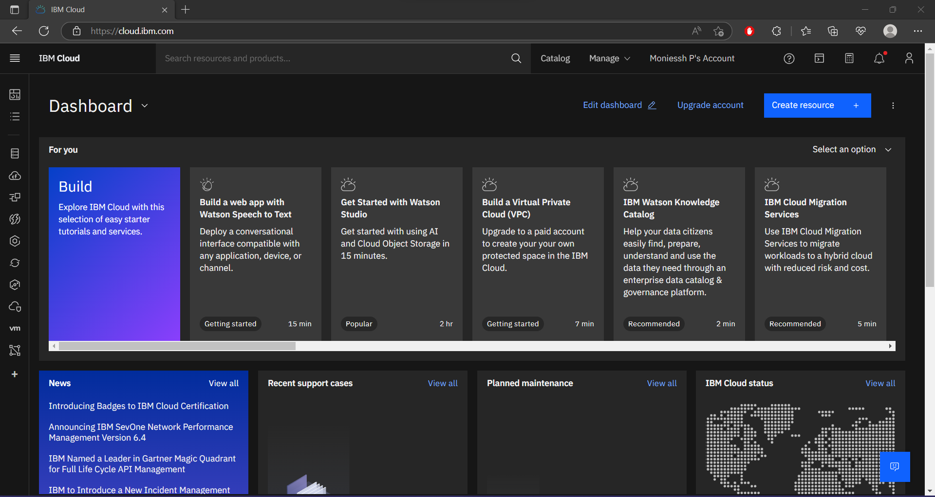

Team member 1- Kishore Kumar L

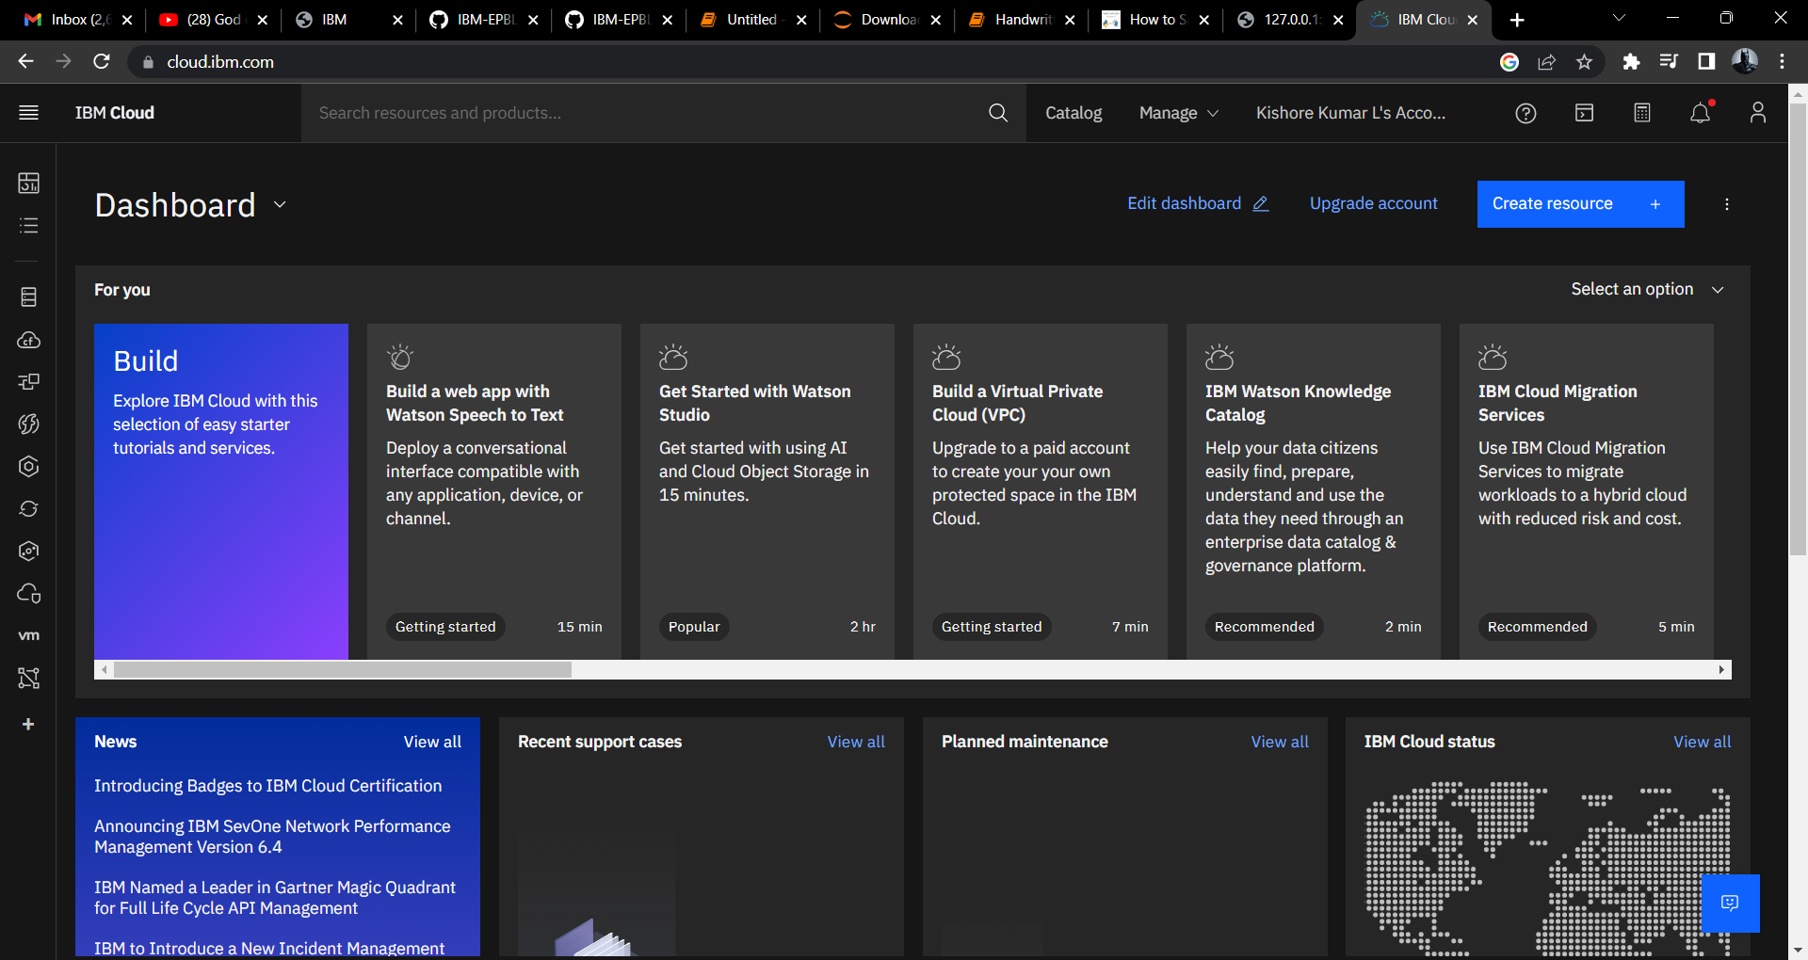

Team member 2- Shyam Gopal

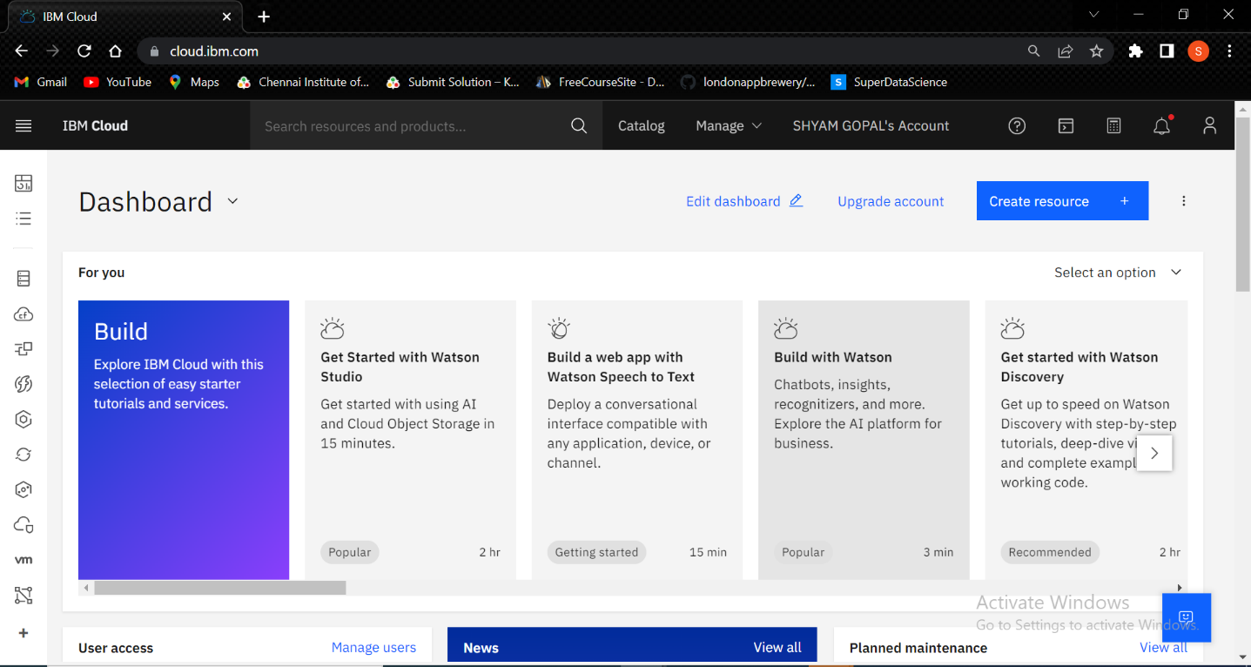

Team member 3- Tarun K

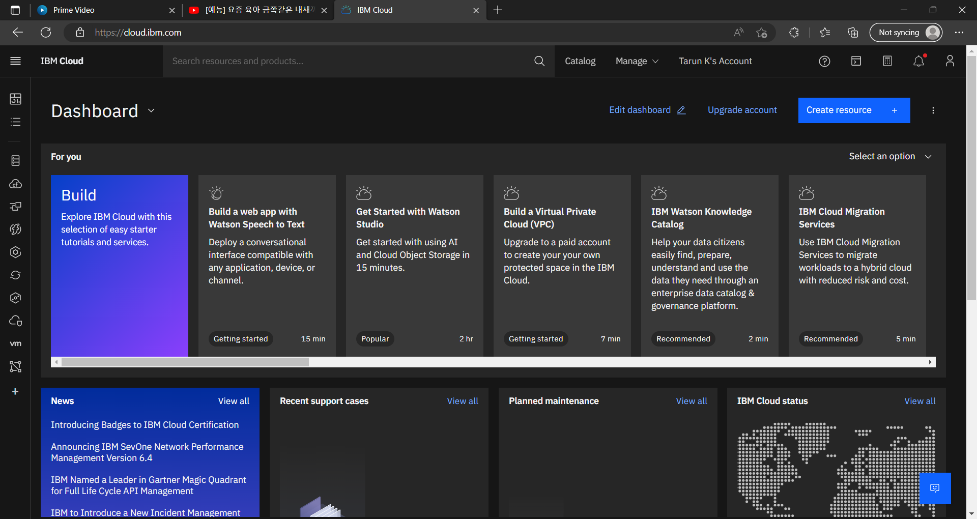

Step-15 To check the free trial details click on the manage dropdown from the top navigation bar and click on account.

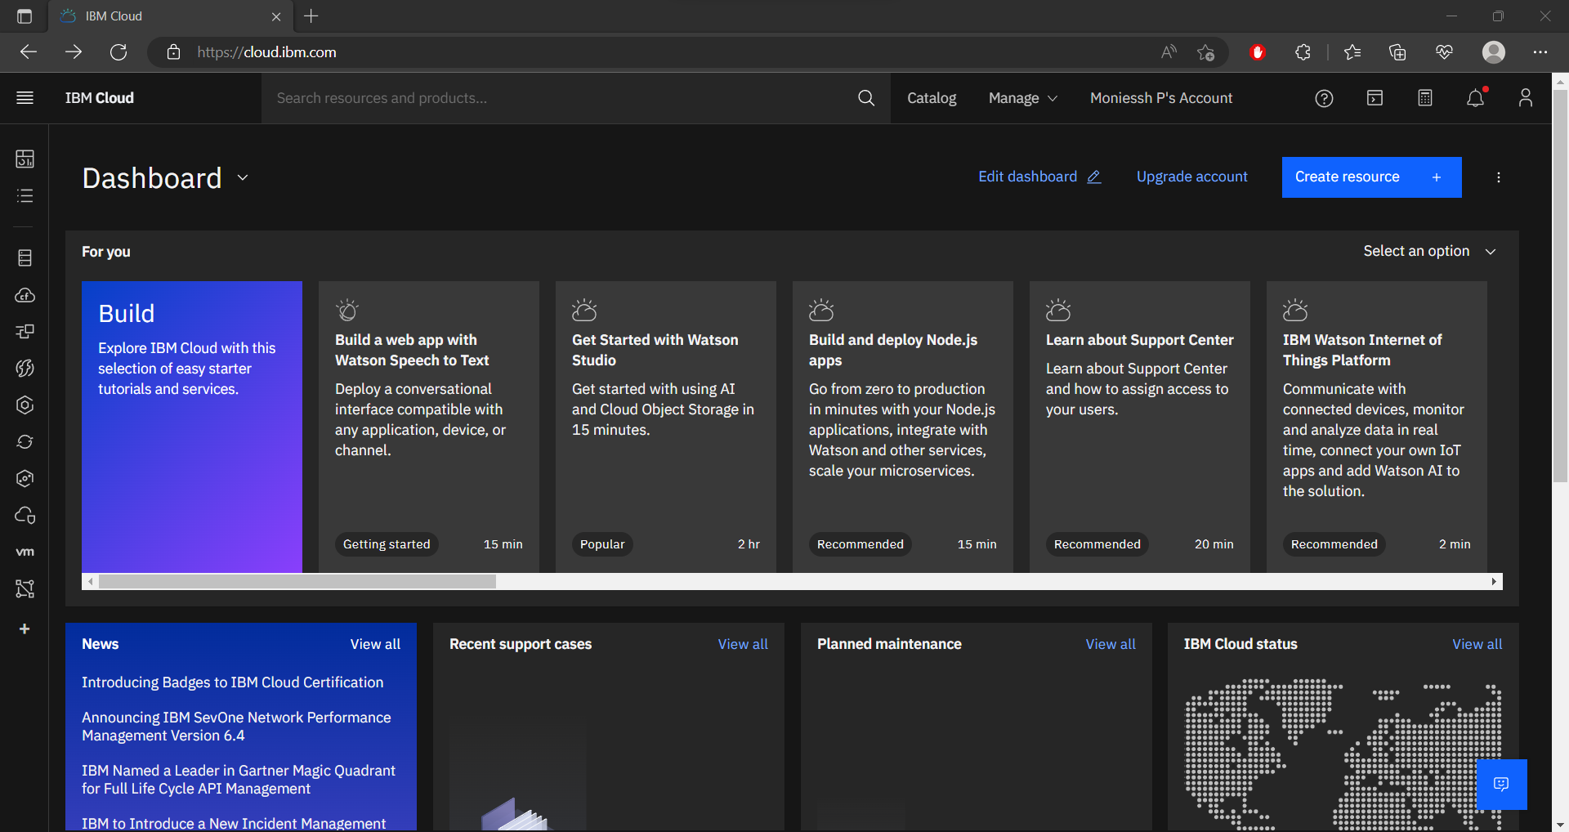

Step-16 Go to Account settings to check Free trial details

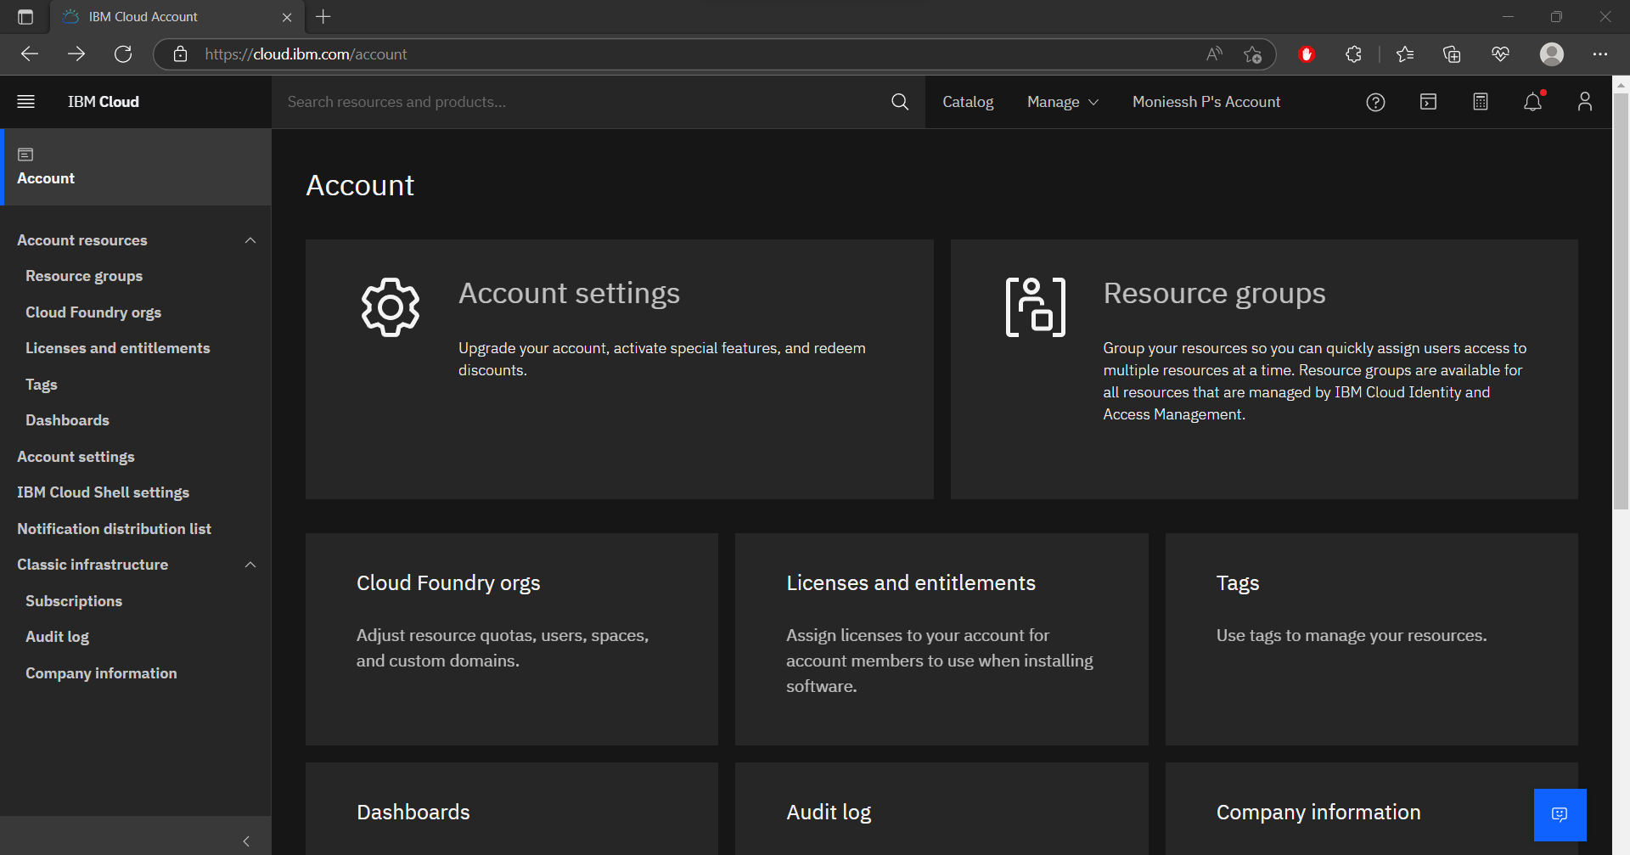

Step-17 Good Job! You created 395 Days Free trial account successfully.

